Assignment No. 8

6CS371 : Advanced Database System Lab

Installation and Setup of Distributed Database System

Name : Jay Shirgupe

PRN: 21510026

Batch: T-7

TY CSE

Aim

To install and setup a distributed database using MySQL cluster.

Introduction

In contemporary computing, the deployment of distributed database systems is pivotal for ensuring scalability, fault tolerance, and high availability. This assignment focuses on the practical implementation of a distributed database environment using MySQL Cluster, a leading solution in this domain.

Procedure

1. Create an InnoDB Cluster Sandbox Configuration. These sandbox instances will act as nodes in our cluster.

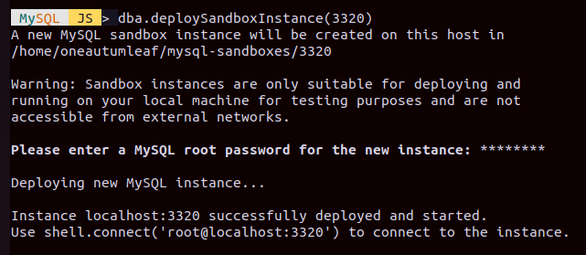

1. Create InnoDB Clusters.

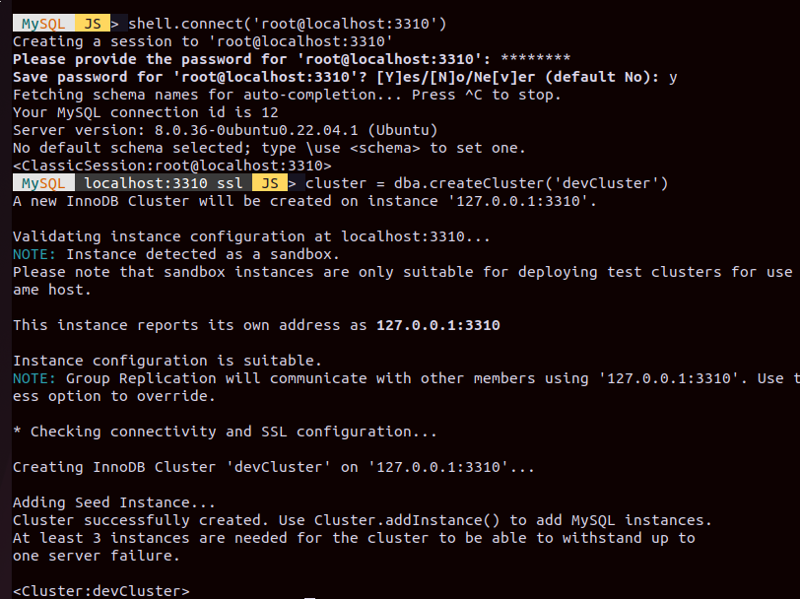

1. Add another mysql server to the cluster. When prompted for a recovery method we will select clone as the recovery method. This will make it so that each server will be a clone of the primary server.

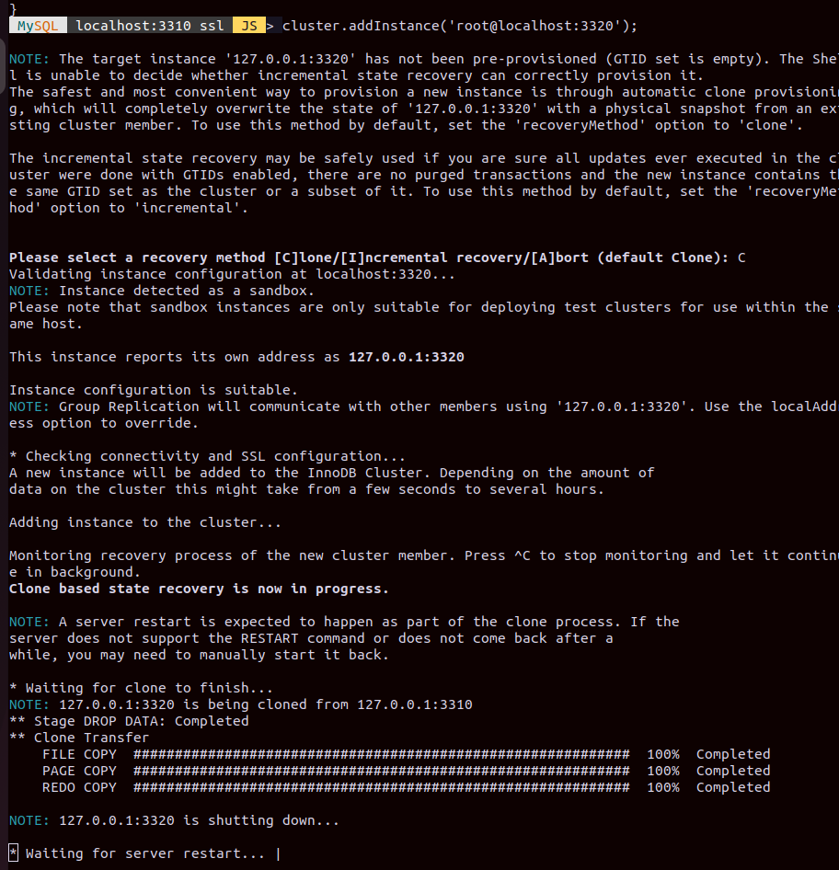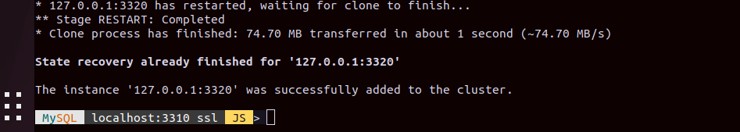

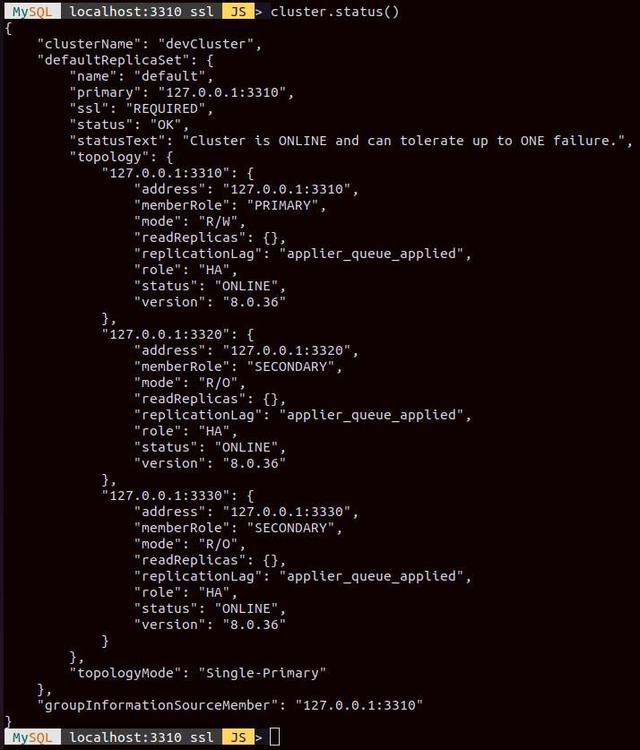

1. Bootstrapping MySQL Router

After MySQL InnoDB Cluster is set up, test the high availability of the Cluster. For this purpose, use MySQL Router. If one instance fails, the MySQL Router updates its routing configuration automatically and ensures that new connections are routed to the remaining instances.

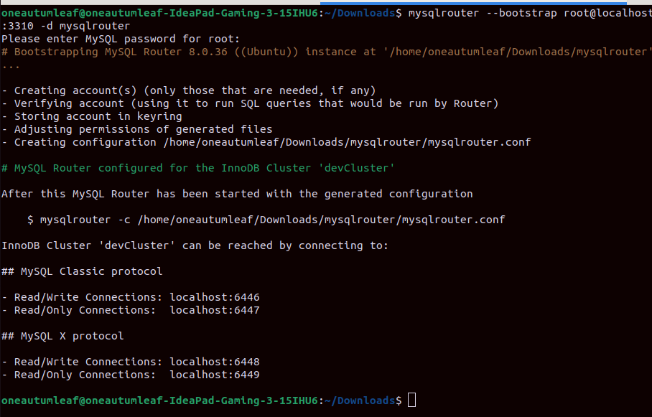

Start the mysql router

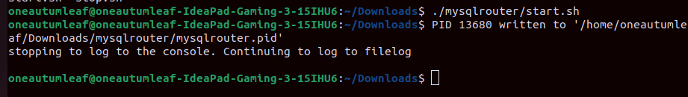

Now the distributed database is available for read/write at localhost:6448 and for read-only at 6449.

1. Testing the cluster

We see which ports are active

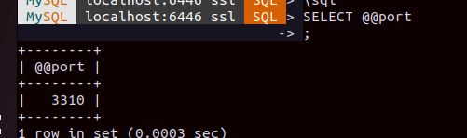

Then we kill the instance used

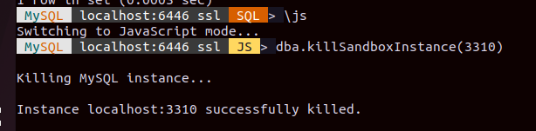

Then check if the cluster is still active or failed.

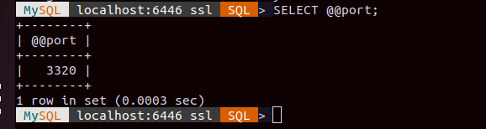

As we can see, once the server at port 3310 went down, the server at port 3320 took it’s place.

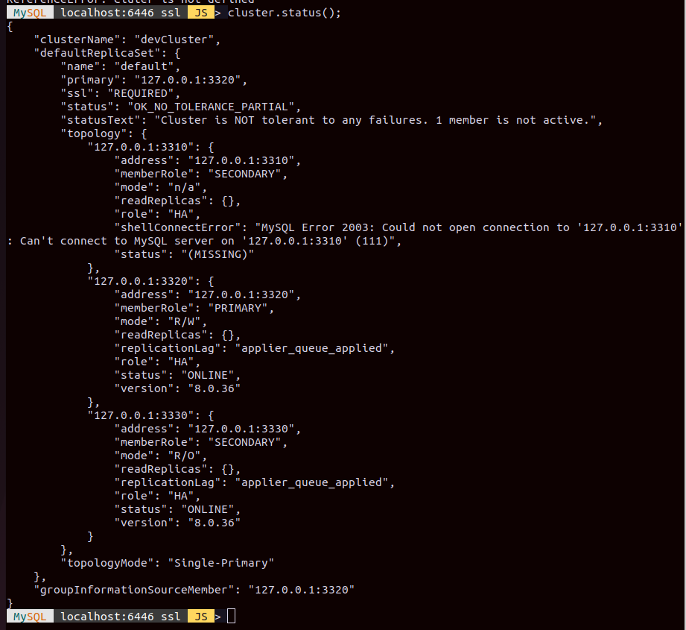The MySQL Server instance formally running on port 3310 is MISSING.

Conclusion

In conclusion, this assignment underscores the practical application of distributed database principles through the deployment of MySQL Cluster. By leveraging clustering techniques, we have established a fault tolerant and scalable distributed database.

References

<https://dev.mysql.com/doc/mysql-shell/8.0/en/setting-up-innodb-cluster-and-mysql-router.html>